KE21S -

Functionality
To test valuation in detail or to run a detailed analysis of errors, you can simulate valuation for the different points of valuation. The screen that appears matches that for manual line item entry, but no values are posted.
From this screen, you can use the valuation analysis described above, as well as the separate condition and access analyses.
Thus you can test various valuations without actually posting SD billing documents e.g. Material cost estimate for cost of goods sold when qty of sales is entered.

Scenario
Simulate the valuation of a Manual Planning entry (version 0), for material 20000239 and plant 1200.

Requirements

Operating concern environment is active.

Menu Path | Accounting → Accounting → Controlling → Profitability Analysis → Tools → Analyze Value Flows → KE21S - Simulate Valuation
Transaction Code | KE21S

1. Double click on KE21S - Simulate Valuation.

Valuation Simulation CO-PA: Initial Screen

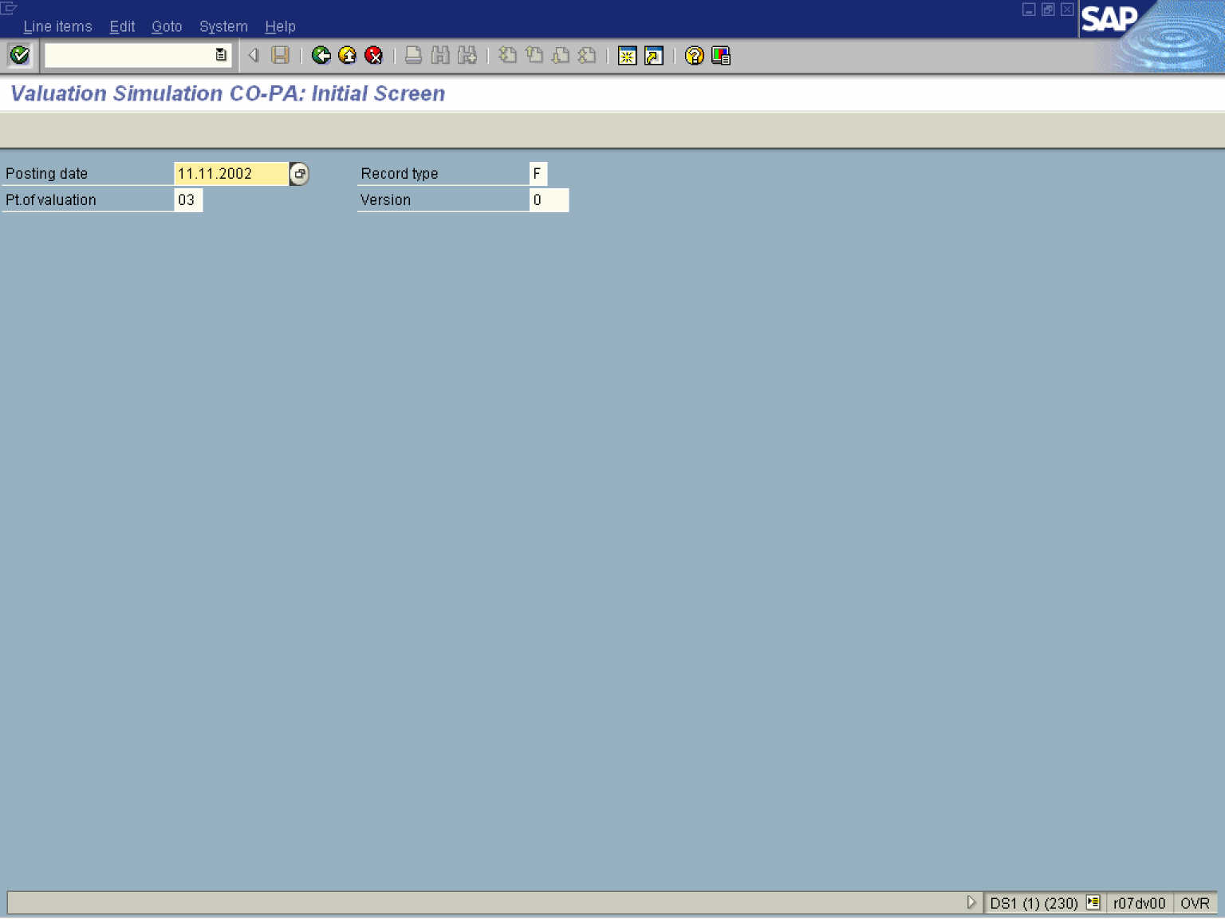

2. Update the following fields:

Field Name | Field Description | Values
Posting date | Posting date | Example: 11.11.2002
Record type | Type of business transaction: billing (record type 'F') or incoming sales orders (record type 'A') in Sales and Distribution (SD), allocation of cost center costs (record type 'D'), and settlement of orders or projects (record type 'C'). | Example: F
Pt. of valuation | Profitability Analysis recognizes four points of valuation: 01 Real time valuation of actual data; 02 Periodic valuations of actual data; 03 Manual planning; 04 Automatic planning. | Example: 03
Version | Plan version | Example: 0
3. Click the Enter button.

Valuation Simulation CO-PA

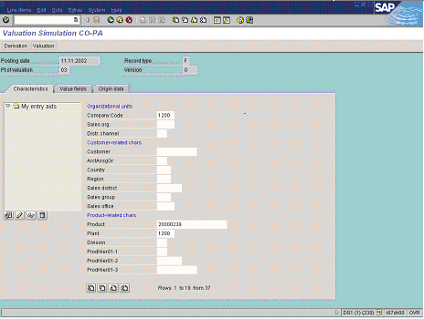

4. Update the following fields on the Characteristics tab:

Field Name | Field Description | Values
Company Code | Code identifying the company. | Example: 1200
Product | The Product. | Example: 20000239
Plant | Code identifying the operational unit of the company where the material is manufactured and stored | Example: 1200

5. Click the Value fields tab button.

Valuation Simulation CO-PA

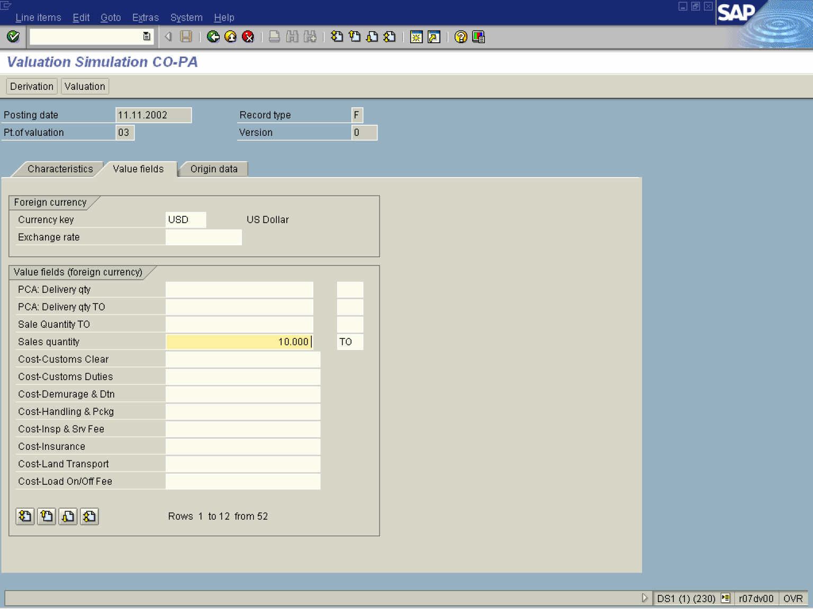

6. Update the following fields on the Value Field tab:

Field Name | Field Description | Values
Sales quantity | The planned sales quantity. | Example: 10
Unit | Unit of measure. | Example: TO

7. Click the Enter button.

8. Click the Valuation button.

Valuation Simulation CO-PA

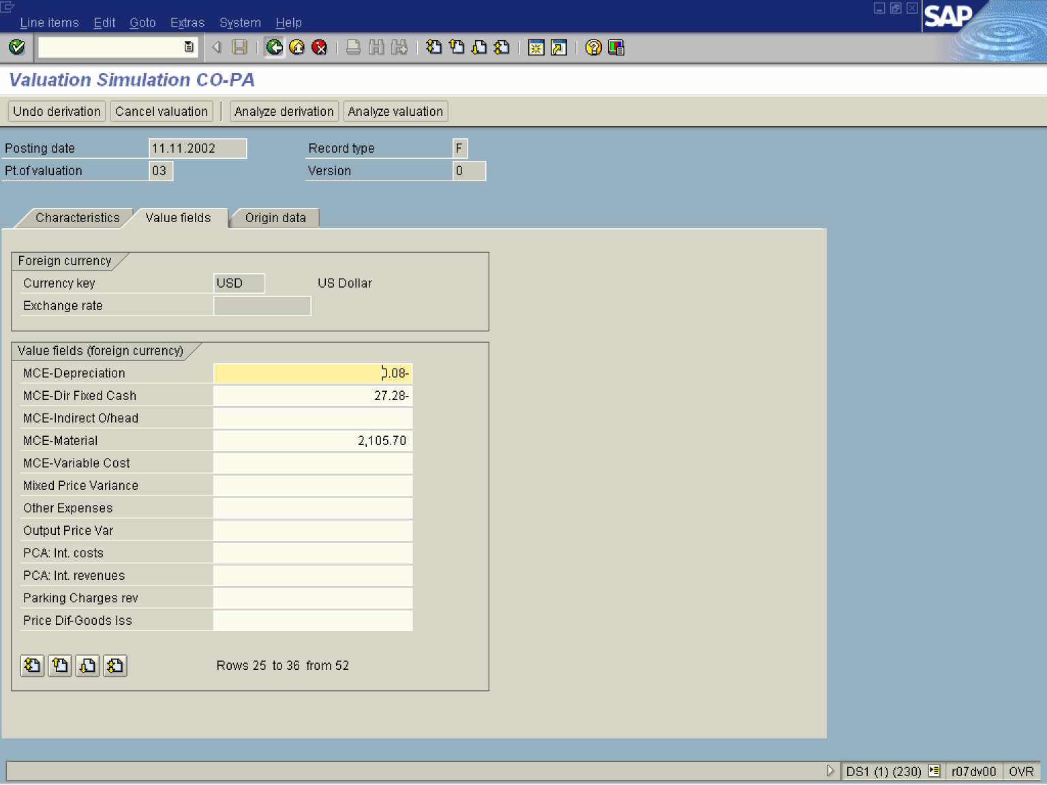
Note: As a result of the valuation, value fields will be populated with figures if there was a cost estimate available for the material. This is in the case of Manufacturing Affiliates, but in the case of Non-Manufacturing Affiliates, no breakdown of cost will be available, where materials will be valuated based on the future price in the material master.

Tip: To analyze valuation steps in detail way click the Analyze valuation 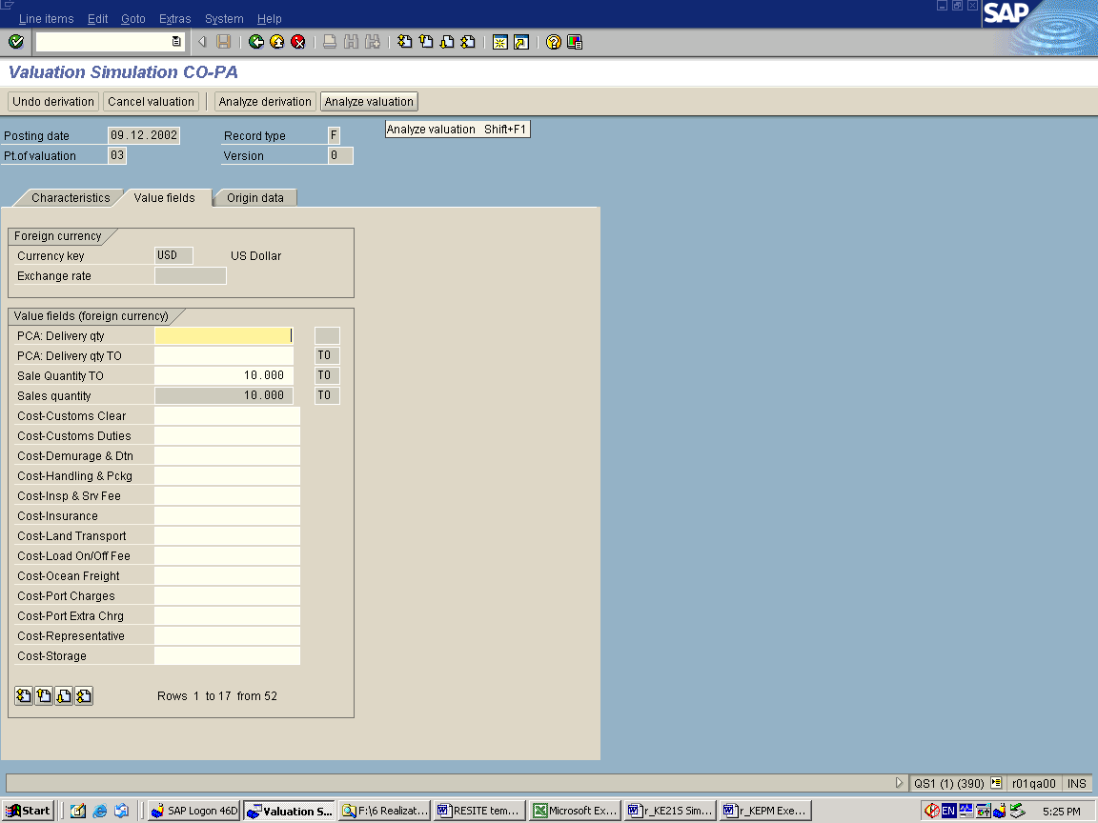 button.

9. Click the Back button to go back to the SAP Easy Access screen.

